Added highlighted part for gate protection and battery noise filtering.

(gate protection will not work unless there are no spikes in battery voltage).

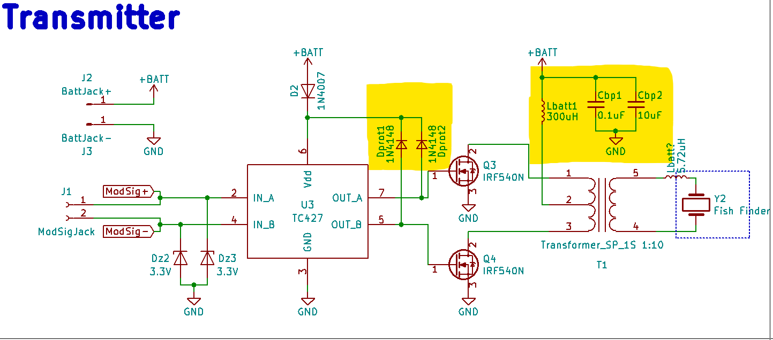

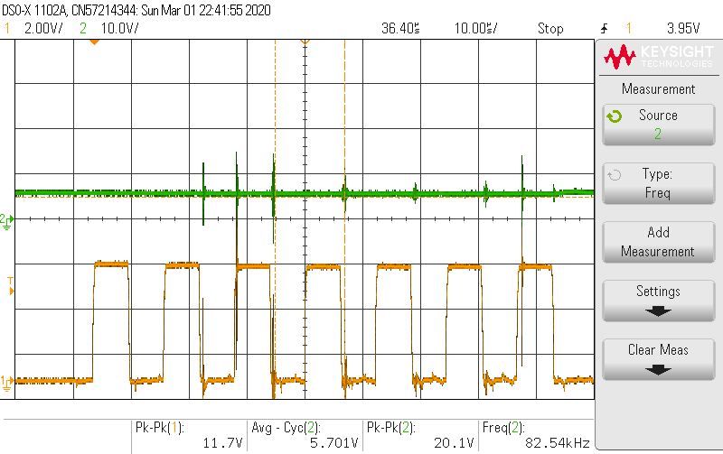

Orange: Voltage at Gate:

Green: Power supply voltage.